1.
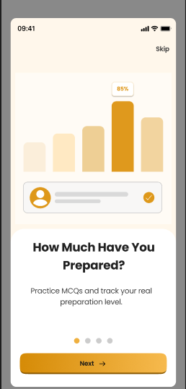

import io.appium.java_client.AppiumBy;
import io.appium.java_client.android.AndroidDriver;
import io.appium.java_client.android.options.UiAutomator2Options;
import org.openqa.selenium.By;
import org.openqa.selenium.WebElement;

import java.net.URL;
import java.time.Duration;

public class PreparationScreenTest {

public static void main(String[] args) throws Exception {

// Desired Capabilities
UiAutomator2Options options = new UiAutomator2Options();
options.setDeviceName("Android Device");
options.setPlatformName("Android");
options.setAutomationName("UiAutomator2");

// App Details
options.setAppPackage("your.package.name");
options.setAppActivity("your.activity.name");

// Driver Setup
AndroidDriver driver = new AndroidDriver(
new URL("http://127.0.0.1:4723"),
options
);

driver.manage().timeouts().implicitlyWait(Duration.ofSeconds(10));

// =========================
// Automation Start
// =========================

// Verify Skip Button
WebElement skipBtn = driver.findElement(
By.xpath("//android.widget.TextView[@text='Skip']")
);

if (skipBtn.isDisplayed()) {
System.out.println("Skip button displayed");
}

// Verify Percentage Text
WebElement percentage = driver.findElement(
By.xpath("//android.widget.TextView[@text='85%']")
);

System.out.println("Percentage Value: " + percentage.getText());

// Verify Heading
WebElement heading = driver.findElement(
By.xpath("//android.widget.TextView[@text='How Much Have You Prepared?']")
);

if (heading.isDisplayed()) {
System.out.println("Heading displayed successfully");
}

// Verify Description
WebElement description = driver.findElement(
By.xpath("//android.widget.TextView[contains(@text,'Practice MCQs')]")
);

System.out.println(description.getText());

// Verify Next Button
WebElement nextButton = driver.findElement(
By.xpath("//android.widget.TextView[@text='Next']")
);

if (nextButton.isDisplayed()) {
System.out.println("Next button visible");
}

// Click Next Button
nextButton.click();

System.out.println("Clicked on Next Button");

// Close App
driver.quit();
}
}

2/Second page we automate now
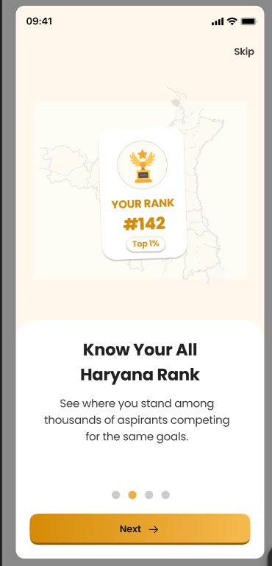

import io.appium.java_client.android.AndroidDriver;
import io.appium.java_client.android.options.UiAutomator2Options;
import org.openqa.selenium.By;
import org.openqa.selenium.WebElement;

import java.net.URL;
import java.time.Duration;

public class HaryanaRankScreen {

public static void main(String[] args) throws Exception {

// ==========================
// 1. Mobile Configuration
// ==========================

// Ye object mobile ki details store karta hai
UiAutomator2Options options = new UiAutomator2Options();

// Device ka naam set kar rahe hain
options.setDeviceName("Android Device");

// Platform Android hai
options.setPlatformName("Android");

// Automation engine
options.setAutomationName("UiAutomator2");

// App package name
// Ye app ka unique naam hota hai
options.setAppPackage("your.package.name");

// App activity name
// App ka starting screen
options.setAppActivity("your.activity.name");

// ==========================
// 2. Driver Start
// ==========================

// Appium server se connection ban raha hai
AndroidDriver driver = new AndroidDriver(
new URL("http://127.0.0.1:4723"),
options
);

// 10 second wait karega element dhundhne ke liye
driver.manage().timeouts().implicitlyWait(Duration.ofSeconds(10));

// ==========================
// 3. Skip Button Locate
// ==========================

// Skip button ko text se locate kiya
WebElement skipButton = driver.findElement(
By.xpath("//android.widget.TextView[@text='Skip']")
);

// Check kar rahe hain button visible hai ya nahi
if(skipButton.isDisplayed()) {

System.out.println("Skip Button Display Ho Raha Hai");
}

// ==========================
// 4. Rank Card Verify
// ==========================

// YOUR RANK text locate kiya
WebElement rankText = driver.findElement(
By.xpath("//android.widget.TextView[@text='YOUR RANK']")
);

// Console me print karwa diya
System.out.println(rankText.getText());

// ==========================
// 5. Rank Number Verify
// ==========================

// #142 locate kiya
WebElement rankNumber = driver.findElement(
By.xpath("//android.widget.TextView[@text='#142']")
);

// Rank number print hoga
System.out.println("Rank Number : " + rankNumber.getText());

// ==========================
// 6. Top Percentage Verify
// ==========================

// Top 1% locate kiya
WebElement topPercent = driver.findElement(
By.xpath("//android.widget.TextView[@text='Top 1%']")
);

// Value print
System.out.println(topPercent.getText());

// ==========================
// 7. Heading Verify
// ==========================

// Main heading locate
WebElement heading = driver.findElement(
By.xpath("//android.widget.TextView[@text='Know Your All Haryana Rank']")
);

// Heading visible check
if(heading.isDisplayed()) {

System.out.println("Heading Visible Hai");
}

// ==========================
// 8. Description Verify
// ==========================

// Description text locate
WebElement description = driver.findElement(
By.xpath("//android.widget.TextView[contains(@text,'See where you stand')]")
);

// Description print
System.out.println(description.getText());

// ==========================
// 9. Next Button Verify
// ==========================

// Next button locate
WebElement nextButton = driver.findElement(
By.xpath("//android.widget.TextView[@text='Next']")
);

// Check visible hai ya nahi
if(nextButton.isDisplayed()) {

System.out.println("Next Button Visible Hai");
}

// ==========================
// 10. Next Button Click
// ==========================

// Next button click
nextButton.click();

System.out.println("Next Button Click Ho Gaya");

// ==========================
// 11. App Close
// ==========================

// Driver band kar diya
driver.quit();
}
}
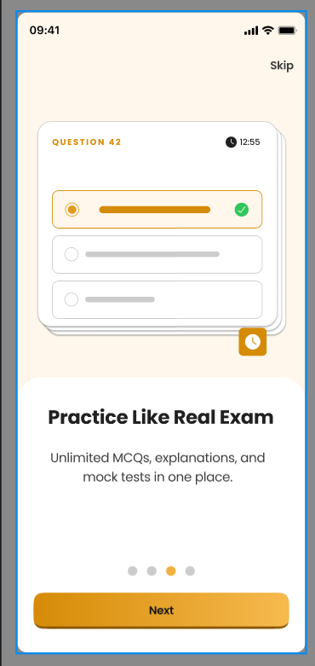

import io.appium.java_client.android.AndroidDriver;
import io.appium.java_client.android.options.UiAutomator2Options;
import org.openqa.selenium.By;
import org.openqa.selenium.WebElement;

import java.net.URL;
import java.time.Duration;

public class PracticeLikeRealExam {

public static void main(String[] args) throws Exception {

// =====================================
// 1. Mobile Configuration
// =====================================

// Mobile settings store karne ke liye object
UiAutomator2Options options = new UiAutomator2Options();

// Device ka naam
options.setDeviceName("Android Device");

// Platform Android
options.setPlatformName("Android");

// Automation Engine
options.setAutomationName("UiAutomator2");

// App package name
options.setAppPackage("your.package.name");

// App activity name
options.setAppActivity("your.activity.name");

// =====================================
// 2. Driver Initialize
// =====================================

// Appium server se connect kar rahe hain
AndroidDriver driver = new AndroidDriver(
new URL("http://127.0.0.1:4723"),
options
);

// 10 second ka implicit wait
driver.manage().timeouts().implicitlyWait(Duration.ofSeconds(10));

// =====================================
// 3. Skip Button Verify
// =====================================

// Skip button locate
WebElement skipButton = driver.findElement(
By.xpath("//android.widget.TextView[@text='Skip']")
);

// Check visible hai ya nahi
if(skipButton.isDisplayed()) {

System.out.println("Skip Button Visible Hai");
}

// =====================================
// 4. Question Number Verify
// =====================================

// QUESTION 42 text locate
WebElement questionText = driver.findElement(
By.xpath("//android.widget.TextView[@text='QUESTION 42']")
);

// Console me print
System.out.println(questionText.getText());

// =====================================
// 5. Timer Verify
// =====================================

// Timer locate
WebElement timer = driver.findElement(
By.xpath("//android.widget.TextView[@text='12:55']")
);

// Timer value print
System.out.println("Timer : " + timer.getText());

// =====================================
// 6. Selected Option Verify
// =====================================

// Selected option locate
WebElement selectedOption = driver.findElement(
By.xpath("(//android.view.View)[5]")
);

// Check visible
if(selectedOption.isDisplayed()) {

System.out.println("Selected Option Visible Hai");
}

// =====================================
// 7. Heading Verify
// =====================================

// Heading locate
WebElement heading = driver.findElement(
By.xpath("//android.widget.TextView[@text='Practice Like Real Exam']")
);

// Check heading visible
if(heading.isDisplayed()) {

System.out.println("Heading Visible Hai");
}

// =====================================
// 8. Description Verify
// =====================================

// Description locate
WebElement description = driver.findElement(
By.xpath("//android.widget.TextView[contains(@text,'Unlimited MCQs')]")
);

// Print description
System.out.println(description.getText());

// =====================================
// 9. Pagination Dots Verify
// =====================================

// Dots locate
WebElement dots = driver.findElement(
By.xpath("(//android.view.View)[15]")
);

// Check dots visible
if(dots.isDisplayed()) {

System.out.println("Pagination Dots Visible Hai");
}

// =====================================
// 10. Next Button Verify
// =====================================

// Next button locate
WebElement nextButton = driver.findElement(
By.xpath("//android.widget.TextView[@text='Next']")
);

// Verify button
if(nextButton.isDisplayed()) {

System.out.println("Next Button Visible Hai");
}

// =====================================
// 11. Next Button Click
// =====================================

// Next button click
nextButton.click();

System.out.println("Next Button Click Ho Gaya");

// =====================================
// 12. Close App
// =====================================

// App close
driver.quit();
}
}

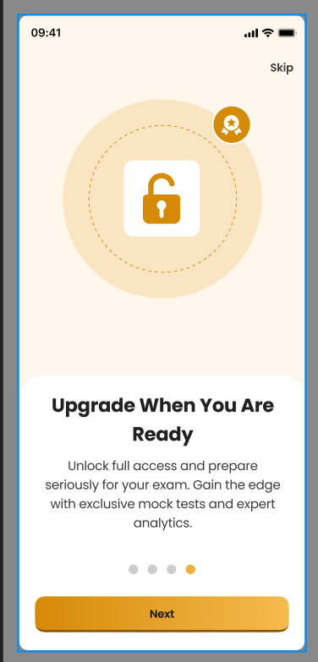

// जरूरी Appium और Selenium की libraries import कर रहे हैं
import io.appium.java_client.AppiumDriver;
import io.appium.java_client.MobileBy;
import io.appium.java_client.android.AndroidDriver;
import org.openqa.selenium.By;
import org.openqa.selenium.WebElement;
import org.openqa.selenium.remote.DesiredCapabilities;
import java.net.URL;
public class UpgradeScreenTest {
public static void main(String[] args) throws Exception {
// Mobile capabilities सेट कर रहे हैं
// ये Appium को बताते हैं कि कौनसी device और कौनसा app run करना है
Desired Capabilities caps = new Desired Capabilities();
// Android platform define किया
caps.setCapability("platformName", "Android");
// Device का नाम दिया
caps.setCapability("device Name", "Android Emulator");
// Automation engine बताया (Android के लिए UiAutomator2)
caps.setCapability("automation Name", "UiAutomator2");
// App का path दिया
// यहाँ अपनी APK file का सही path डालना है
caps.setCapability("app", "C:\\Apps\\examapp.apk");
// Appium server से connection बना रहे हैं
Appium Driver driver = new Android Driver(
new URL("http://127.0.0.1:4723"),
caps
);
// App open होने के बाद 5 सेकंड wait
Thread.sleep(5000);
// ===============================
// Screen Validation Start
// ===============================
// "Upgrade When You Are Ready" text को locate किया
WebElement title = driver.findElement(
By.xpath("//android.widget.TextView[@text='Upgrade When You Are Ready']")
);
// Title print किया
System.out.println("Screen Title : " + title.getText());
// नीचे वाला description text locate किया
WebElement description = driver.findElement(
By.xpath("//android.widget.TextView[contains(@text,'Unlock full access')]")
);
// Description print किया
System.out.println("Description : " + description.getText());
// ===============================
// Next Button Click
// ===============================
// "Next" button को locate किया
WebElement nextButton = driver.findElement(
By.xpath("//android.widget.TextView[@text='Next']")
);
// Button पर click किया
nextButton.click();
// Console में message print किया
System.out.println("Next button clicked successfully");
// ===============================
// Skip Button Click Example
// ===============================
// अगर Skip button पर click करना हो
WebElement skipButton = driver.findElement(
By.xpath("//android.widget.TextView[@text='Skip']")
);
// Skip button click
skipButton.click();
// Console message
System.out.println("Skip button clicked successfully");
// ===============================
// App Close
// ===============================
// Driver बंद कर रहे हैं
driver.quit();
}
}

